Name:
Teacher:

DO NOT OPEN THE EXAMINATION PAPER UNTIL
YOU ARE TOLD BY THE SUPERVISOR TO BEGIN

PHYSICS 2204
FINAL EXAMINATION
June 2012
Value: 80 marks
General Instructions
This examination consists of two parts. Both parts are contained in this booklet and further general instructions are provided on appropriate pages.
Part I – Multiple Choice (40 marks)
Select the letter of the correct response from those provided. EITHER shade the letter on your computer scorable card OR place the letter in the blank provided on your Multiple Choice Answer Sheet, whichever format is being used by your school for this exam. Do ALL questions in this section.

Part II – Constructed Response (40 marks)
Answer ALL questions fully and concisely in the space provided.
A Formulae Sheet is provided.
Student Checklist
The items below are your responsibility. Please ensure that they are completed.
□ Write your name and teacher’s name on the top of this page.
□ Write your name, teacher’s name, course name and number on the Part I answer sheet.
□ Check the exam to see that there are no missing pages.
ALL MATERIALS MUST BE PASSED IN WITH THIS EXAM. Use your time wisely. Good luck!

Part I
Total Value: 40 Marks

1. Which is a vector quantity?
(A) Distance
(B) Speed
(C) Time
(D) Velocity

2. A hiker walks 3.00 km [N] then 4.00 km [S]. What is the magnitude of her displacement?
(A) 1.00 km
(B) 5.00 km
(C) 7.00 km
(D) 25.0 km

3. Which graph shows uniform POSITIVE acceleration?
t
d
0
(A)

t
d
0

(B)

t
v
0

(C)

t
v
0

(D)

4. What does the slope of a tangent drawn to a point on a curved displacement versus time graph represent?
(A) Average speed
(B) Average velocity
(C) Instantaneous speed
(D) Instantaneous velocity

5. A car accelerates from rest at $3.0$ m/s² for 5.0 s. What is its final velocity?
(A) 0.6 m/s
(B) 1.7 m/s
(C) 15 m/s
(D) 45 m/s

6. Which motion is depicted in the graph?

V
(m/s)
0
t (s)

(A) A ball is dropped and it bounces back to its original height
(B) A car slows down as it approaches a stop sign
(C) A frog jumps up and falls back toward the ground
(D) A skydiver jumps from a plane

7. A stone is thrown straight downward from a 15 m high bridge. If it hits the water at 22 m/s, what was its initial velocity?
(A) 11 m/s [down]
(B) 14 m/s [down]
(C) 28 m/s [down]
(D) 330 m/s [down]

8. Car A travels at 110 km/h [W] while Car B travels at 75 km/h [E]. What is the velocity of Car A relative to Car B?
(A) 35 km/h [E]
(B) 35 km/h [W]
(C) 185 km/h [E]
(D) 185 km/h [W]

9. A swimmer heads 1.8 m/s [W] in a river where the current is 1.1 m/s [S]. What is the magnitude of the swimmer’s velocity relative to the shore?
(A) 0.7 m/s
(B) 2.1 m/s
(C) 2.9 m/s
(D) 4.5 m/s

10. What is the net force acting on a shopping cart of mass 25.0 kg, experiencing an acceleration of 2.50 m/s²?
(A) 10.0 N
(B) 22.5 N
(C) 27.5 N
(D) 62.5 N

11. Which law states “For every action force there is an equal and opposite reaction force”?
(A) Newton’s Law of Universal Gravitation
(B) Newton’s First Law of Motion
(C) Newton’s Second Law of Motion
(D) Newton’s Third Law of Motion

12. Four different rockets all start from rest. Which rocket will have the lowest velocity after 10 s?
(A) A 100 kg rocket with a net force of 100 N
(B) A 200 kg rocket with a net force of 400 N
(C) A 300 kg rocket with a net force of 900 N
(D) A 400 kg rocket with a net force of 4000 N

13. What is the magnitude of the net force on the car in the diagram?

3000 N
5000 N
15000 N
15000 N

(A) 2000 N
(B) 8000 N
(C) 15000 N
(D) 20000 N

14. A tool cabinet experiences a normal force of 610 N and a frictional force of 150 N. What is the coefficient of friction?
(A) 0.016
(B) 0.25
(C) 0.41
(D) 2.4

15. What are the horizontal and vertical components of the force shown?
620 N

25°

 | Horizontal | Vertical
(A) | 262 N | 289 N
(B) | 262 N | 562 N
(C) | 562 N | 262 N
(D) | 562 N | 289 N

16. A traffic light is hanging motionless on a single, vertical chain. Which statement is correct regarding tension in the chain (T) and the force of gravity on the light (F_{g})?
(A) T = 0
(B) T < F_{g}
(C) T = F_{g}
(D) T > F_{g}

17. What happens to the force of gravity acting between two masses if their separation increases by a factor of 2?
(A) Decreases by a factor of 2
(B) Decreases by a factor of 4
(C) Increases by a factor of 2
(D) Increases by a factor of 4

18. What is the momentum of a 20.0 kg coyote running at 4.00 m/s?
(A) 5.00 kg·m/s
(B) 16.0 kg·m/s
(C) 24.0 kg·m/s
(D) 80.0 kg·m/s

19. A golf ball is struck with a force of 8.0 N for a contact time of 0.15 s. What is the impulse on the ball?
(A) 0.12 N·s
(B) 0.83 N·s
(C) 1.2 N·s
(D) 8.2 N·s

20. A lynx with a mass of 18.0 kg is stalking its prey at 1.50 m/s. It speeds up to 6.50 m/s to catch the prey. What is the change in momentum of the lynx?
(A) 1.50 kg·m/s
(B) 3.60 kg·m/s
(C) 90.0 kg·m/s
(D) 117 kg·m/s

21. A force applied to a box does 22.0 J of work while moving the box 4.50 m. What is the magnitude of the applied force?
(A) 4.89 N
(B) 10.1 N
F
(C) 17.5 N
(D) 26.5 N

22. Two students with the same mass run up a flight of stairs. If student A runs twice as fast as student B, which statement is true?
(A) Student A did more work.
(B) Student A generated more power.
(C) Student B did more work.
(D) Student B generated more power.

23. A 950 kg car accelerates from rest to 7.0 m/s. How much work is done on the car?
(A) 3300 J
(B) 6700 J
(C) 23000 J
(D) 47000 J

24. What is the gravitational potential energy of a 1.50 kg bag of flour resting on a kitchen shelf 1.90 m above the floor? (g = 9.80 m/s²)
(A) 3.40 J
(B) 14.7 J
(C) 18.6 J
(D) 27.9 J

25. Which expression represents Hooke’s Law?
(A) F = µF_{N}
(B) F = kx
(C) F = ma
(D) F = mg

26. A wooden block of mass 1.2 kg attached to a horizontal spring on a frictionless surface is displaced 0.25 m from its equilibrium position. What is the magnitude of the acceleration at that position if the spring constant is 18 N/m?
(A) 0.017 m/s²
(B) 0.56 m/s²
(C) 3.8 m/s²
(D) 4.5 m/s²

27. What is the elastic potential stored in a spring of spring constant 3.5 N/m when it is extended by 0.85 m?
(A) 1.3 J
(B) 1.5 J
(C) 2.2 J
(D) 2.5 J

28. A child is sliding down a water slide. By what factor would the height need to be changed in order to double the child’s speed at the bottom?
(A) ¼
(B) ½
(C) 2
(D) 4

29. A crane is 78% efficient when lifting a load. If the crane does 1500 J of work, what is the output energy?
(A) 19 J
(B) 1200 J
(C) 1900 J
(D) 12000 J

30. A student counts 8 waves hitting the beach in 22 s. What is the period of the waves?
(A) 0.36 s
(B) 2.8 s
(C) 22 s
(D) 180 s

31. What is the wavelength of the wave shown below?
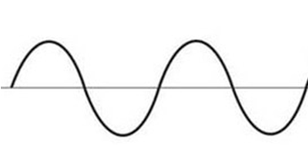
0
24 cm
36 cm
12 cm

(A) 6.0 cm
(B) 12 cm
(C) 24 cm
(D) 36 cm

32. Which point is in phase with point X?
X
A
B
C
D
(A) A

(B) B

(C) C

(D) D

33. What is the speed of light in sapphire with an index of refraction of 1.77?
(A) 1.23 × 10⁸ m/s
(B) 1.69 × 10⁸ m/s
(C) 3.00 × 10⁸ m/s
(D) 5.31 × 10⁸ m/s

34. The apparent location (image) of a fish is shown. Where must the spear fisherman aim in order to strike the fish?

C
A
B
D
(A) A
(B) B
(C) C
(D) D

35. Light is shone on two slits that are separated by a distance of 8.75 × 10⁻⁶ m. If the second order maximum occurs at an angle of 8.21° from the center line, what is the wavelength of light?
(A) 6.25 × 10⁻⁷ m
(B) 1.25 × 10⁻⁷ m
(C) 1.25 × 10⁻⁶ m
(D) 6.25 × 10⁻⁶ m

36. If the speed of sound in a classroom is 340 m/s, what is the wavelength of sound from a 256 Hz tuning fork?
(A) 0.0029 m
(B) 0.0039 m
(C) 0.75 m
(D) 1.3 m

37. An aircraft travelling at 233 m/s has a Mach number of 0.770. What is the speed of sound?
(A) 179 m/s
(B) 233 m/s
(C) 303 m/s
(D) 332 m/s

38. An ambulance approaches an observer at 31.5 m/s on a day when the speed of sound is 341 m/s. If the frequency heard is 525 Hz, what is the actual frequency of the siren?
(A) 477 Hz
(B) 481 Hz
(C) 573 Hz
(D) 578 Hz

39. What is the wavelength produced when a 0.78 m long guitar string vibrates in its second overtone?
(A) 0.26 m
(B) 0.52 m
(C) 0.78 m
(D) 1.5 m

40. Which pair of tuning forks will give a beat frequency of 2 Hz when sounded together?
(A) 220 Hz and 440 Hz
(B) 220 Hz and 222 Hz
(C) 440 Hz and 880 Hz
(D) 440 Hz and 444 Hz

End of Part I

PART II
Total Value: 40 marks

Answer ALL questions in the space provided. Show all your workings.

Value

41. (a) Use the graph to answer the questions below.
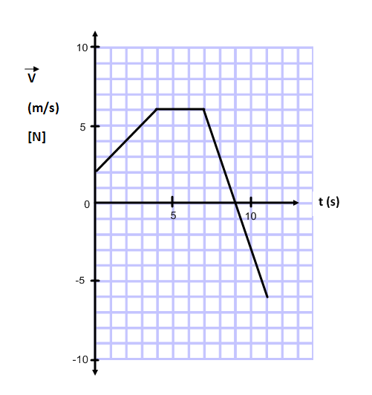
2 (i) Calculate the acceleration at 10 s.

2 (ii) Calculate the displacement from 0 s to 4 s.

1 (iii) At what time is the object at rest?

1 (iv) During which time interval is the object travelling at a constant velocity?

3 (b) A car is travelling at a constant velocity of 28 m/s when the driver sees a moose 75 m ahead. The brakes are then applied, causing the car to accelerate at – 6.4 m/s². What was the maximum reaction time the driver had to apply the brakes and avoid hitting the moose?

(Note: Space on the page has been left in the event you would like to include a diagram.)

42. (a) Two masses are connected by a massless string over a frictionless pulley. There is a frictional force of 8.5 N acting on the 5.0 kg cart.

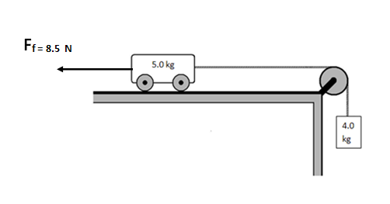
3 (i) Calculate the acceleration of the system when the 4.0kg mass is released.

2 (ii) Calculate the tension in the string when the 4.0kg mass is released.

3 (b) A 120 kg ATV moving at 15 m/s collides with a stationary 35 kg barbeque. If they stick together on impact, what is their common final velocity?

3 (c) In the “Wreckhouse” area, the winds can cause windows to break with gusts up to 180 km/h. Calculate the force on a window if 40.0 kg of air moving at 180 km/h strikes a window over a contact time of 0.20 s. Assume the air stops moving when it hits the glass.

3 43. (a) Using principles of Physics, explain which one of these Olympic weight lifters is doing the most work.

Lifter A raises a 50 kg mass 2m vertically from the floor.

Lifter B holds a 50 kg mass at shoulder height and walks 2m forward at a constant velocity.

3 (b) A spring (k = 125 N/m) is used to launch a 0.15 kg toy straight upwards from the ground. If the spring is compressed 0.080 m, what is the maximum height reached by the toy?

3 (c) A light bulb has a power input of 40 W and is only 4.0% efficient. What is the light energy output from the light bulb in a time of 3600s?

44. (a) Use the diagram below to answer the questions.
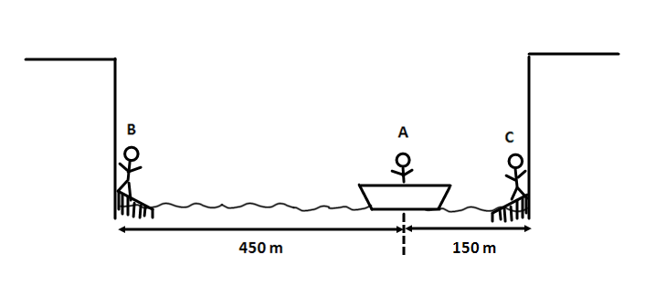

2 (i) When person A calls for help, how long will it take her to hear the echo from the nearest cliff if the speed of sound is 338 m/s?

2 (ii) B and C hear a call for help from A. By what factor does the intensity of the sound heard by B differ from the intensity of the sound heard by C?

(b) A student is planning to conduct an experiment to verify Snell’s Law.

3 (i) As a pre-lab exercise, he attempted to calculate the angle of refraction in air (n = 1.00) using an angle of incidence in water (n = 1.33) of 52°. Determine if the incident ray reflected or refracted.

1 (ii) On the diagram below, sketch the resulting ray when the lab was conducted.

Air n=1.00

Water n=1.33
52°

3 (c) A 440 Hz tuning fork is held over an air column that is open at one end. If the temperature is 19° C, calculate the length of the air column that produces the second resonant sound.

