|  |  |  |  |  |  |  |  |
| --- | --- | --- | --- | --- | --- | --- | --- |
| Question |  |  | Unit | Level | Marks | SCO | Pg. # |
| 41 | A | i | 1 | 2 | 2 | 325-2 | 26 |
|  |  | ii | 1 | 2 | 2 | 325-2 | 26 |
|  |  | iii | 1 | 2 | 1 | 325-2 | 26 |
|  |  | iv | 1 | 2 | 1 | 325-2 | 26 |
|  |  |  |  |  |  |  |  |
|  | b(STSE) |  | 1 | 3 | 3 | 325-2 | 30 |
|  |  |  |  |  |  |  |  |
| 42 | a | i | 2 | 2 | 3 | 325-8 | 48 |
|  |  | ii | 2 | 2 | 2 | 325-8 | 48 |
|  |  |  |  |  |  |  |  |
|  | b(STSE) |  | 2 | 2 | 3 | 326-3 | 54 |
|  |  |  |  |  |  |  |  |
|  | c(STSE) |  | 2 | 3 | 3 | 326-3 | 52 |
|  |  |  |  |  |  |  |  |
| 43 | a |  | 3 | 3 | 3 | 325-9 | 58 |
|  |  |  |  |  |  |  |  |
|  | b |  | 3 | 2 | 3 | 326-1 | 66 |
|  |  |  |  |  |  |  |  |
|  | c |  | 3 | 2 | 3 | 325-10, 326-8 | 68 |
|  |  |  |  |  |  |  |  |
| 44 | a | i | 4 | 2 | 2 | 327-5, 327-6, 327-7 | 88 |
|  |  | ii | 4 | 2 | 2 | 327-5, 327-6, 327-7 | 88 |
|  |  |  |  |  |  |  |  |
|  | b | i | 4 | 3 | 3 | 327-7, 327-8 | 84 |
|  |  | ii | 4 | 2 | 1 |  | 84 |
|  |  |  |  |  |  |  |  |
|  | c(lab) |  | 4 | 2 | 3 | 327-5, 327-8 | 92 |

**PART II**

**Total Value: 40 marks**

Answer **ALL** questions in the space provided. *Show all your workings.*

*Value*

41. (a) Use the graph to answer the questions below.

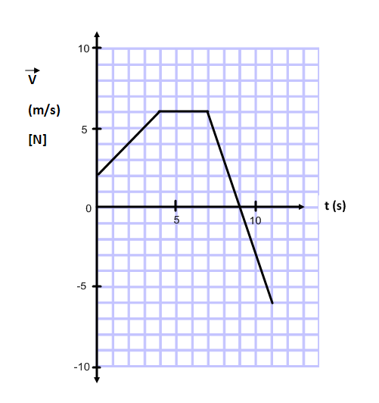

2 (i) Calculate the acceleration at 10 s.



2 (ii) Calculate the displacement from 0 s to 4 s.



1 (iii) At what time is the object at rest?



1 (iv) During which time interval is the object travelling at a constant velocity?



3 (b) A car is travelling at a constant velocity of 28 m/s when the driver sees a moose 75 m ahead. The brakes are then applied, causing the car to accelerate at – 6.4 m/s2. What was the maximum reaction time the driver had to apply the brakes and avoid hitting the moose?

(Note: Space on the page has been left in the event you would like to include a diagram.)



42. (a) Two masses are connected by a massless string over a frictionless pulley. There is a frictional force of 8.5 N acting on the 5.0 kg cart.

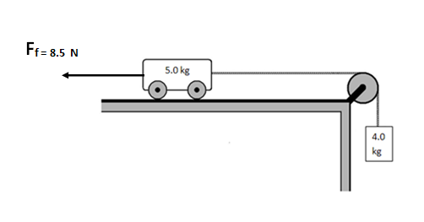

Fg

T

T

3 (i) Calculate the acceleration of the system when the 4.0kg mass is released.



2 (ii) Calculate the tension in the string when the 4.0kg mass is released.



3 (b) A 120 kg ATV moving at 15 m/s collides with a stationary 35 kg barbeque. If they stick together on impact, what is their common final velocity?



3 (c) In the “Wreckhouse” area, the winds can cause windows to break with gusts up to 180 km/h. Calculate the force on a window if 40.0 kg of air moving at 180 km/h strikes a window over a contact time of 0.20 s. Assume the air stops moving when it hits the glass.



3 43. (a) Using principles of Physics, explain which one of these Olympic weight lifters is doing the most work.

Lifter A raises a 50 kg mass 2m vertically from the floor.

Lifter B holds a 50 kg mass at shoulder height and walks 2m forward at a constant velocity.

Lifter A does more work. (1 mark)

This is because a force is applied to lift the mass and the mass moves in the direction of the applied force. (1 mark)

Lifter B actually does zero work because the mass does not move in the direction of the force or a component of the force. (1 mark)

3 (b) A spring (k = 125 N/m) is used to launch a 0.15 kg toy straight upwards from the ground. If the spring is compressed 0.080 m, what is the maximum height reached by the toy?



3 (c) A light bulb has a power input of 40 W and is only 4.0% efficient. What is the light energy output from the light bulb in a time of 3600s?



44. (a) Use the diagram below to answer the questions.

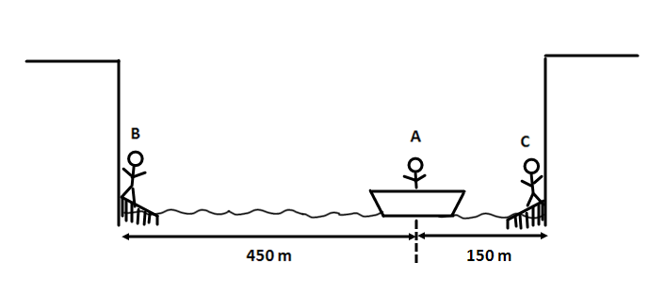

2 (i) When person A calls for help, how long will it take her to hear the echo from the nearest cliff if the speed of sound is 338 m/s?



2 (ii) B and C hear a call for help from A. By what factor does the intensity of the sound heard by B differ from the intensity of the sound heard by C?



(b) A student is planning to conduct an experiment to verify Snell’s Law.

3 (i) As a pre-lab exercise, he attempted to calculate the angle of refraction in air (n = 1.00) using an angle of incidence in water (n = 1.33) of 52°. Determine if the incident ray reflected or refracted.



1 (ii) On the diagram below, sketch the resulting ray when the lab was conducted.

Air n=1.00

Water n=1.33

52°

52o

3 (c) A 440 Hz tuning fork is held over an air column that is open at one end. If the temperature is 19° C, calculate the length of the air column that produces the second resonant sound.

