AP Psychology 4220
Waterford Valley High School

Units
- Brief History of Psychology / Approaches & Research Methodstics
- Biological Bases of Behavior / Neuroscience
- Sensation & Perception
- States of Consciousness 123
- Learning
- Cognition (Memory, Language & Thinking)
- Motivation & Emotion
- Developmental Psychology
- Personality
- Intelligence, Testing and Individual differences
- Abnormal Behavior1& Treatment of Abnormal Behavior1
- Social Psychology 4
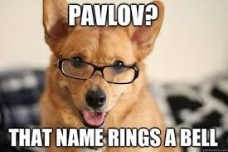
Evaluation
Unit Tests 25%
Quizzes 5%
Assignments 20%
Mid-Year Exam 25%
Final Exam 25%

